<SUBJECT NAME> PROJECT REPORT
(Project Semester August-December 2018)

(TITLE OF THE PROJECT)

Submitted by

(Name of student)

Registration No………...

Programme and Section …………
Course Code ..............

Under the Guidance of

(Name of faculty coordinator with U.Id and designation)

Discipline of CSE/IT

Lovely School of __________________

Lovely Professional University, Phagwara

CERTIFICATE

This is to certify that ........... (student’s name) bearing Registration no. ......... has completed ........... <Course Code> project titled, “.................................” under my guidance and supervision. To the best of my knowledge, the present work is the result of his/her original development, effort and study.

Signature and Name of the Supervisor
Designation of the Supervisor
School of …………………………………………….
Lovely Professional University
Phagwara, Punjab.

Date:

DECLARATION

I, ....................., student of ............................ (Program name) under CSE/IT Discipline at, Lovely Professional University, Punjab, hereby declare that all the information furnished in this project report is based on my own intensive work and is genuine.

Date: Signature
Registration No. ........................... Name of the student

Acknowledgement
I express my sincere gratitude to my project guide _______________________ for their valuable guidance, encouragement, and support throughout the completion of this project. I also thank the Head of the Department and faculty members for providing the necessary resources and support. Finally, I extend my heartfelt thanks to my family and friends for their constant motivation.

Table of Contents
- Introduction
- Scope of the Analysis
- Existing System
3.1 Overview of the Existing System
3.2 Drawbacks or Limitations of the Existing System
- Source of Dataset
- Data Preprocessing and Cleaning
- Data Modelling (Optional)
- Analysis on Dataset
7.1 Introduction
7.2 General Description
7.3 Specific Requirements, Functions and Formulas
7.4 Analysis Results
7.5 Visualizations
- List of Analyses with Results
- Future Scope
- References

1. Introduction
Football is one of the most widely followed sports in the world and generates a massive volume of data every day. Each match produces detailed information related to players, teams, goals, fouls, cards, substitutions, and match outcomes. In the modern era, football clubs, analysts, and coaching staff increasingly rely on data analytics to evaluate performance, identify strengths and weaknesses, and make informed decisions.
Football analytics refers to the systematic analysis of football data to gain actionable insights. With the advancement of technology, tools such as Power BI allow analysts to convert raw data into interactive visual dashboards. These dashboards help stakeholders quickly understand trends, compare player performances, and evaluate team efficiency.
This project focuses on implementing football analytics using Microsoft Power BI. The goal is to analyze historical football data and present insights through visually appealing dashboards that are easy to interpret. The project demonstrates how business intelligence tools can be effectively applied in the domain of sports analytics.

2. Problem Statement
Traditional methods of analyzing football performance rely heavily on manual calculations and static reports. As the volume of football data increases, these methods become inefficient, time-consuming, and prone to errors. Coaches and analysts often struggle to extract meaningful insights from large datasets using conventional approaches.
There is a need for an automated and interactive system that can analyze football data efficiently and present insights in a clear visual format. Such a system should allow users to filter data dynamically, compare players and teams, and track performance metrics easily. This project addresses this problem by using Power BI to build an interactive football analytics dashboard.

3. Objectives of the Project
- To analyze football match and player performance data
- To create interactive dashboards using Power BI
- To visualize key performance indicators (KPIs)
- To derive meaningful insights for better decision-making
- To demonstrate the use of data analytics in sports

4. Scope of the Project
The scope of this project is limited to the analysis of historical football data available in the dataset. The project covers player performance, team statistics, match outcomes, and disciplinary records. Interactive dashboards are created to analyze different aspects of football performance.
The project does not include real-time data streaming or live match analysis. However, the methodology used can be extended in the future to support real-time analytics. The dashboards are designed for analytical and educational purposes and can be used by students, analysts, and football enthusiasts.

5. Dataset Description
The dataset used in this project contains football-related information such as:
- Player Name
- Team Name
- Matches Played / Appearances
- Goals Scored
- Assists
- Yellow Cards
- Red Cards
- Match Results
- Tournament Details
The dataset is collected from publicly available football statistics sources and is stored in CSV/Excel format.

6. Tools and Technologies Used
- Power BI Desktop – Data visualization and dashboard creation
- Microsoft Excel / CSV – Data storage
- DAX (Data Analysis Expressions) – Calculations and measures
- Windows OS – Operating system

7. Power BI Overview
Power BI is a business intelligence tool developed by Microsoft that allows users to connect to multiple data sources, transform data, and create interactive reports and dashboards. It provides features such as slicers, filters, drill-downs, and real-time data interaction.

8. Data Preprocessing and Cleaning
Data preprocessing is a crucial step in any analytics project, as the quality of insights depends on the quality of data. Raw football data often contains missing values, inconsistencies, and redundant records. Before loading the dataset into Power BI, several preprocessing steps were performed.
The following data cleaning techniques were applied:
- Removal of duplicate player and match records
- Handling missing values using appropriate methods
- Standardization of column names for clarity
- Conversion of data types such as dates and numeric fields
- Filtering irrelevant or incomplete records
These steps ensured that the dataset was accurate, consistent, and ready for analysis in Power BI.

9. Data Modeling
Data modeling plays a significant role in Power BI projects. A well-designed data model improves performance and ensures accurate analysis. In this project, relationships were created between multiple tables such as players, teams, matches, and tournaments.
A star schema approach was followed, where fact tables containing match statistics were connected to dimension tables such as player and team details. Proper relationships enabled effective filtering and slicing of data across different visuals. This structure helped in achieving efficient and reliable analytics.

10. DAX Measures and Calculations
DAX (Data Analysis Expressions) is a formula language used in Power BI to create calculated measures and columns. DAX formulas allow dynamic calculations that automatically update based on slicers and filters selected by the user. In this project, several DAX measures were created to analyze football performance effectively.
10.1 Key DAX Measures Used
Total Goals
Total Goals = SUM(Football[Goals])
This measure calculates the total number of goals scored by players.
Total Assists
Total Assists = SUM(Football[Assists])
This measure calculates the total assists provided by players.
Total Appearances
Total Appearances = SUM(Football[Appearances])
This measure calculates the total number of matches played.
Total Yellow Cards
Total Yellow Cards = SUM(Football[YellowCards])
Total Red Cards
Total Red Cards = SUM(Football[RedCards])
Goal Contribution
Goal Contribution = [Total Goals] + [Total Assists]
This measure represents the overall contribution of a player to scoring.
Qualified Players Filter (Appearances ≥ 5)
Qualified Players = IF([Total Appearances] >= 5, 1, 0)
This measure is used to filter players with sufficient match experience.
These DAX measures enable accurate and dynamic analysis across all dashboard pages.

11. Dashboard Design and Pages Description
The Power BI report consists of multiple dashboard pages designed to analyze football data from different perspectives. Each page includes slicers, charts, and KPIs for interactive analysis.
11.1 Slicers Used in the Dashboard
Slicers allow users to filter data dynamically. The following slicers were used across dashboard pages:
- Player Name
- Team Name
- Position (Forward, Midfielder, Defender, Goalkeeper)
- Tournament
- Season / Year
Slicers help users analyze specific players, teams, or tournaments easily.

11.2 Charts and Visualizations Used
The following charts were used in the dashboards:
- KPI Cards: Total Goals, Total Assists, Total Matches
- Bar Charts: Goals by Player, Assists by Player
- Stacked Bar Charts: Yellow Cards vs Red Cards
- Line Charts: Performance trend over seasons
- Tables: Detailed player statistics
These visualizations provide both summary-level and detailed insights.

11.3 Overview Dashboard Page
The Overview page provides a high-level summary of football statistics. KPI cards display total goals, matches, players, and tournaments. Bar charts show team-wise and player-wise goal distribution.
Figure 11.1: Overview Dashboard with KPI cards and summary charts
(Insert Screenshot of Overview Dashboard here)

11.4 Player Performance Dashboard Page
This page focuses on individual player analysis. Bar charts compare goals and assists across players, while tables display appearances and goal contribution. Slicers allow filtering by player, team, and position.
Figure 11.2: Player Performance Dashboard showing goals, assists, and appearances
(Insert Screenshot of Player Performance Dashboard here)

11.5 Discipline Analysis Dashboard Page
This page analyzes disciplinary records using stacked bar charts for yellow and red cards. It helps identify players with frequent fouls and poor discipline.
Figure 11.3: Discipline Analysis Dashboard with yellow and red cards
(Insert Screenshot of Discipline Dashboard here)

12. Analysis and Insights
Analysis and Insights
The dashboards created in Power BI provide several valuable insights into football performance. By using slicers and filters, users can analyze data from multiple perspectives.
Key insights obtained from the analysis include:
- Identification of top goal scorers across tournaments
- Comparison of player performance based on appearances and goal contribution
- Analysis of disciplinary records using yellow and red cards
- Evaluation of team performance across different seasons
These insights can help coaches and analysts make data-driven decisions related to team selection and strategy.

13. Results and Findings
The project successfully achieved its objectives by transforming raw football data into meaningful visual insights. The Power BI dashboards allow users to interact with the data and explore performance trends easily.
The results show that Power BI is an effective tool for sports analytics, offering flexibility, interactivity, and clarity. The findings highlight the importance of data visualization in understanding complex football statistics.

14. Advantages of the System
- Interactive and user-friendly
- Faster analysis compared to manual methods
- Visual representation of complex data
- Easy decision-making support

15. Limitations
- Depends on dataset accuracy
- No real-time data integration
- Limited to historical data

16. Future Enhancements
The current system can be enhanced further in several ways:
- Integration with live football data APIs for real-time analysis
- Advanced predictive analytics using machine learning
- Player performance forecasting
- Deployment of dashboards to Power BI Service for online access
These enhancements can significantly increase the usefulness of the system in professional football analytics.

17. Conclusion
Football analytics using Power BI proves to be an effective approach for analyzing and visualizing sports data. This project highlights the importance of data-driven decision-making in modern football and demonstrates the power of business intelligence tools in sports analytics.

18. References
- Microsoft Power BI Documentation
- Football statistics websites
- Data visualization tutorials
This project uses Power BI to analyze historical FIFA World Cup football data and extract meaningful insights related to tournaments, teams, players, and match outcomes. The dashboards are designed to provide a clear, interactive, and visual understanding of football performance over different years.
The analysis is divided into three dashboards:
- Tournament Overview Dashboard – focuses on tournament-level insights such as goals, hosts, matches, and World Cup titles.
- Team Performance Dashboard – focuses on team-wise performance metrics like wins, goals scored, goals conceded, and win rate.
- Player & Discipline Analysis Dashboard – focuses on player contributions and disciplinary actions such as yellow and red cards.
Interactive slicers such as Year, Host Country, Team, Player Name, and Position allow users to dynamically filter the data and analyze specific scenarios. This makes the dashboards highly useful for data-driven sports analysis and decision-making.

DASHBOARD 1: TOURNAMENT OVERVIEW DASHBOARD
Purpose
This dashboard provides a high-level overview of FIFA World Cup tournaments from 1930 to 2022, focusing on goals, hosting countries, and title distribution.

Visualizations Explanation
1. KPI Cards (Top Section)
- Goals per Match (2.91)
Shows the average number of goals scored per match across all tournaments, indicating the overall attacking nature of the game.
- Total Tournaments (30)
Displays the total number of World Cup tournaments held.
- Total Matches (1K)
Represents the total number of matches played across all tournaments.
- Goals per Tournament (4K)
Indicates the total number of goals scored across all World Cups.
👉 These KPIs give a quick summary of the dataset at a glance.

2. Slicers (Year & Host Country)
- Select Tournament Year
Allows users to filter analysis by a specific World Cup year or view all years together.
- Select Host Country
Filters the dashboard based on the country that hosted the tournament.
👉 These slicers make the dashboard interactive and dynamic.

3. World Cup Titles by Country (Donut Chart)
This visualization shows the number of World Cup titles won by each country.
- Brazil leads with the highest number of titles.
- Italy, Germany, Argentina, and France follow.
- Other countries have fewer wins.
👉 This helps identify historically dominant football nations.

4. Matches Hosted by Country (Bar Chart)
This chart displays the number of matches hosted by each country.
- Countries like France, USA, Germany, and Brazil have hosted the most matches.
- Indicates infrastructure capability and repeated hosting.
👉 Useful for understanding host country involvement.

5. Goals per Tournament (1930–2022) – Line Chart
This line chart shows the trend of total goals scored in each tournament over time.
- Older tournaments had fewer goals.
- Modern tournaments show higher goal counts due to:
  - More matches
  - Improved playing styles
  - Advanced fitness and tactics
👉 Highlights the evolution of football over decades.

Dashboard 1 Screenshot:

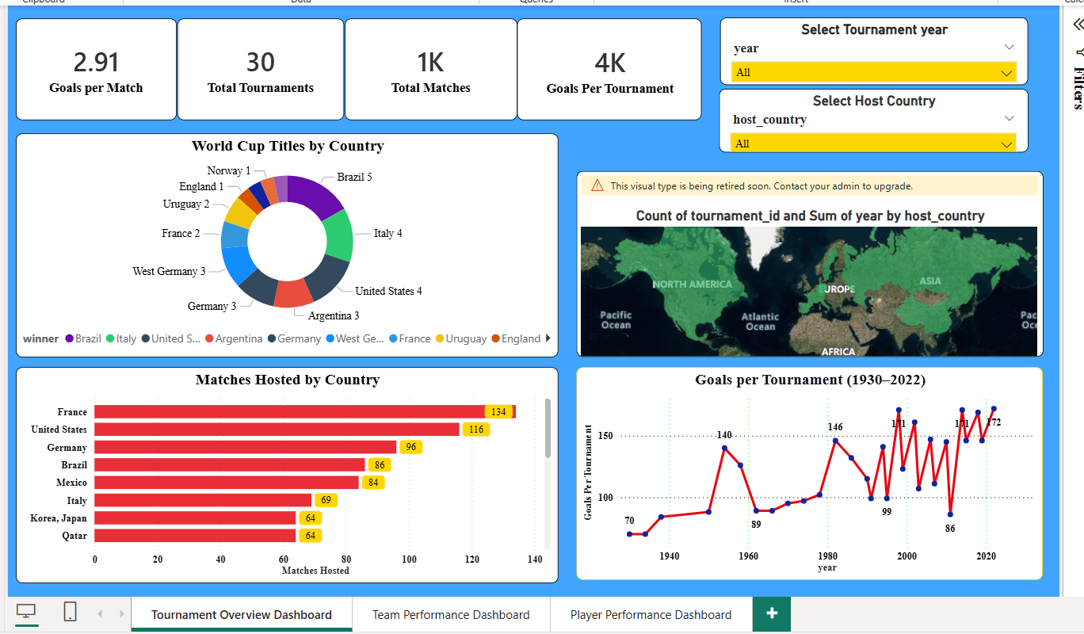

DASHBOARD 2: TEAM PERFORMANCE DASHBOARD
Purpose
This dashboard focuses on team-wise performance analysis, allowing users to evaluate how a selected team has performed across tournaments.

Visualizations Explanation
1. Team Selector (Slicer)
- Allows users to select a specific team (e.g., France).
- All visuals update automatically based on the selected team.

2. KPI Cards (Team Metrics)
- Matches Played (48)
Total matches played by the selected team.
- Goals Scored (103)
Total goals scored by the team.
- Goals Conceded (51)
Total goals conceded by the team.
- Wins (32)
Number of matches won.
- Draws (7)
Number of matches drawn.
- Losses (9)
Number of matches lost.
- Win Rate % (0.67)
Win percentage of the team.
- Average Goals per Match (2.15)
Indicates attacking efficiency.
👉 These KPIs provide a complete performance summary.

3. Goals Scored vs Goals Conceded (Line Chart)
This visualization compares goals scored and goals conceded across tournament years.
- Higher gap indicates stronger offensive dominance.
- Years with high conceded goals show defensive weakness.
👉 Helps analyze team balance between attack and defense.

4. Match Outcome Breakdown (Horizontal Bar Chart)
Displays the percentage distribution of wins, draws, and losses.
- Win percentage is highest.
- Loss and draw percentages are comparatively lower.
👉 Gives a clear view of consistency and dominance.

5. Wins by Tournament Year (Column Chart)
Shows the number of wins achieved in each tournament year.
- Peaks indicate strong tournament performances.
- Useful for identifying golden eras of a team.

Dashboard 2 screenshot:
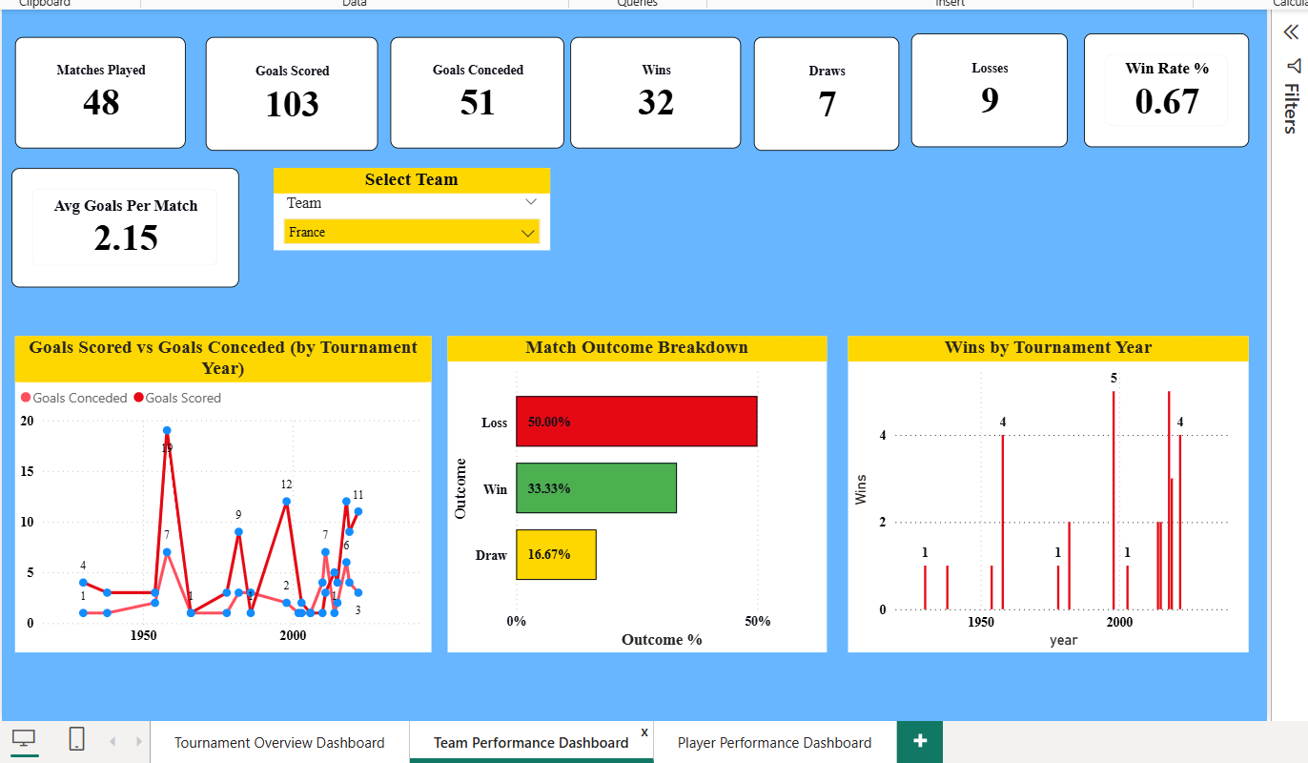

DASHBOARD 3: PLAYER & DISCIPLINE ANALYSIS DASHBOARD
Purpose
This dashboard analyzes individual player contributions and disciplinary trends in World Cup tournaments.

Visualizations Explanation
1. Player & Position Slicers
- Name Slicer – Select a specific player.
- Position Slicer – Filter players by Forward, Midfielder, Defender, or Goalkeeper.
👉 Enables player-level drill-down analysis.

2. KPI Cards (Player Metrics)
- Goals Scored by Player
- Player Appearances
- Yellow Cards Count
- Red Cards Count
👉 These cards summarize individual performance and discipline.

3. Goals per Tournament & Goals Scored by Player (Combined Chart)
This visualization compares:
- Total goals scored in each tournament
- Goals scored by a selected player
👉 Helps understand individual contribution vs tournament scale.

4. Red Cards and Yellow Cards by Year (Line Chart)
Shows disciplinary trends over time.
- Yellow cards are significantly higher than red cards.
- Peaks indicate aggressive or highly competitive tournaments.
👉 Useful for analyzing discipline patterns and rule enforcement changes.

OVERALL INSIGHTS
- Football has become more goal-oriented over time.
- Certain countries consistently dominate World Cups.
- Team performance varies significantly across eras.
- Player contributions and discipline play a major role in match outcomes.

Dashboard 3 screenshot
